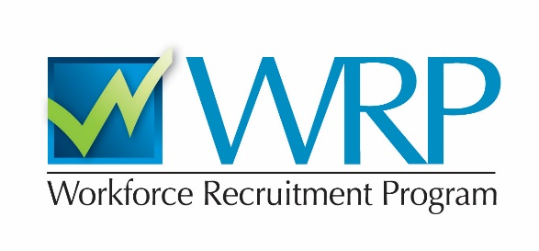

**Are you a student or recent graduate with a disability seeking an internship or job?**

**A WRP Recruiter will be interviewing students from your school this fall!**

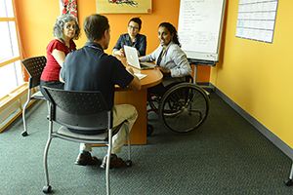**Picture of two men standing in business suits, talking. One is holding some papers and the other is holding a cane and a briefcase.**

**The WRP is a recruitment program for students and recent graduates with disabilities, and serves as a primary pipeline for bringing new talent into the federal government. Applying is an excellent way to:**

* **Find an internship or permanent position at federal agencies**
* **Explore careers in the federal service**
* **Gain interviewing experience**

**Registration is open for six weeks starting August 27th at** [**www.wrp.gov**](http://www.wrp.gov)**.**

**For more information, contact:**

**Terri Massie-Burrell // tmassie1@jhu.edu**