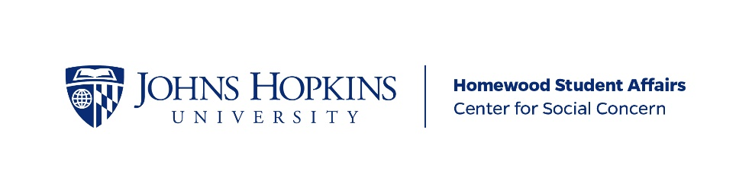
CSC Event-Based Service Program Guiding Document

Official Name of Event-Based Service Program:

Date this document was last updated:

MISSION STATEMENT
Your mission statement should answer the following questions: what does your event-based service program do, how do you do it, and why do you do it? Your mission should relate to a community-identified need, either JHU or Baltimore community. Please note—this paragraph will appear on the CSC website and in a list of student service initiatives.

STATEMENT OF NEED
Please describe in more detail the community-identified need your event-based service program addresses. How have you examined and evaluated this need? Who is your target audience(s)? What gaps in programming are you filling in support of your community partner and, ultimately, your target audience? Statistics and other data are helpful—consider the following sources, in addition to information from your community partner: Baltimore City Health Department (http://health.baltimorecity.gov/node/23), the Baltimore Neighborhood Indicators Alliance (http://bniajfi.org/), and City-Data.com (http://www.city-data.com/city/Baltimore-Maryland.html).

INTERNAL ORGANIZATION AND PROCESSES

What expectations do you have of potential members (i.e. number of hours required, meeting attendance requirements, involvement in pre-event planning and post-event logistics, potential day-of tasks, delegation of tasks among group members)?

How frequently do you meet on campus to discuss and plan details of your event(s), reflect on your event(s), and plan for future events?

How are officer duties broken up within your event-based service program? How do you ensure officer accountability for delegated responsibilities?

How does your service program manage the election process and appoint new officers? When does this process take place?

How do you support the transition process for new officers? For example, do new officers shadow outgoing officers, do you have a shared Dropbox or Google Drive account, or do you provide the information in another way? How do you make sure new officers have access (passwords, login info) for service program resources? (For assistance with transition planning, please reach out to the Group Management Interns or your advisor)

EVENT-BASED SERVICE EXPERIENCE

What kind of events does your service program put on? When?

Please describe a typical event-based volunteer experience for your group.

How do you ensure that civic engagement components remain at the forefront of any planning and facilitation of your event(s)?

How do you train volunteers to ensure they have the skills necessary to serve well and represent your service program well at your event(s)?

