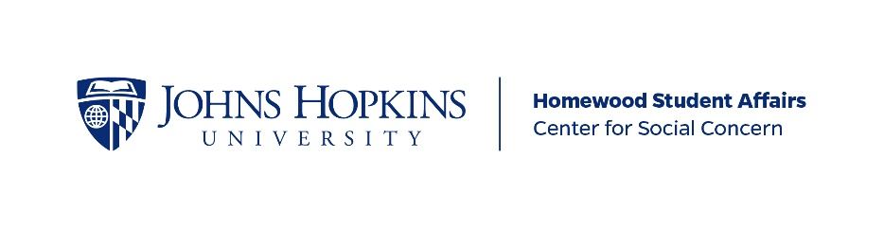

CSC Baltimore First Individualized Direct Service Site
Guiding Document

Name of Community Organization:

Name of Primary Community Partner Contact:
Community Partner Contact Email Address:
Primary Partner Contact Phone Number:

Primary Student Contact:
Primary Student Contact Email Address:

Date this document was last updated:

DESCRIPTION OF SERVICE SITE & COMMUNITY PARTNER RELATIONSHIP
Your description should answer the following questions: What is the vision and/or mission of your community partner? One of the central tenets of Baltimore First’s model is building and maintaining a consistent relationship with and commitment to a community organization. How have you built or intend to build such a reciprocal relationship with your community partner?

SERVICE EXPERIENCE
Please describe a typical volunteer experience at your service site. What do JHU volunteers do at the service site? How frequently are your volunteers expected to serve? How long is a typical service shift?

STATEMENT OF PURPOSE
How does this service relate to one or more community-identified need(s) in the Baltimore community and/or of the community organization? Who is/are your target audience(s)? What gap in services and/or programming are you filling in support of your community partner and, ultimately, your target audience?

