Student Activities Commission (SAC) Funding Policies
General Guidelines

Application Guidelines
- Annual Budgets:
  - Groups may apply for an annual budget during the re-registration period that occurs each spring semester. To receive funds a group must re-register through Hopkins Groups.
    - The deadline for the application period will be determined by the SLI office each school year.
  - The S.A.C. will post deadlines and filing procedures on its website, and will notify primary contact of the student group of any pertinent information regarding budget procedures.
  - The most up to date annual budget form will be available on the S.A.C. and SLI website.
  - It is the responsibility of the primary contact to ensure that complete proposals are submitted to and received by the S.A.C.
  - Annual budgets should be in an excel format with the following name or the document will not be accepted: category_groupname.xlsx.
  - S.A.C. will not fund any annual grant submission that does not fill out the latest submission form or does not complete the whole document.
  - If a submission has inconsistent request amounts, only the smallest value will be considered. Both of the main pages of the submission should always add up to the same dollar amount.
  - Unless an updated document is requested, the S.A.C. will not accept any late submissions.
  - S.A.C. reserves the right to ask a student organization for an updated request document for the following reasons:
    - An old version of the form was submitted
    - The submission was misplaced
    - The submission is corrupted
    - The submission does not meet the rest of these guidelines
    - An incorrect file was submitted
- Monthly Grants
  - All monthly grant allotments will be determined at the end of every meeting but will take two weeks for the money to be disseminated into the account of the student group.
  - Groups may apply for a S.A.C. grant through the Johns Hopkins University Student Government Association page on Hopkins Groups.
  - Monthly grants will be accepted if they meet any of the following criteria:
    - An Unexpected Expense: A cost not accounted for in the annual budget
      - Example of an unexpected cost: School AV costs increase or the university requires more security than expected.
      - Not unexpected expenses: More people wanted to come than originally planned.
    - A New Initiative or Event
    - S.A.C. has requested for the grant after the primary contact has previously communicated with a commissioner.
  - Previously requested events and ventures will not be funded again if allocation is incorrectly spent.
  - The name of the monthly grant budget file submitted should be formatted as follows or the file will not be examined: Year_Month_Group Name.xlsx
  - The S.A.C. will meet following each submission deadline to review proposals and approve funding grants, at its discretion.
  - S.A.C will not choose how much to give each organization until reviewing all submissions for a given meeting.
  - S.A.C. will allow groups to come to meetings to inform the organization about a grant with the following stipulations:
    - This process will be on a first-come first-serve basis in which the first group to ask through an email to sac@jhu.eduwill be the first request processed.
    - The S.A.C. will accommodate no more than 4 groups per meeting.
    - Each group shall be allotted a timeslot of 10 minutes.
    - S.A.C. will only accept requests from groups asking for more than $900 with a specific reason why they wish to speak with the group.
    - All student groups must come prepared and be able to add pertinent information to their application.
- Grant Proposals
  - Criteria for request to be considered:
    - Request must provide a benefit to the campus community
    - Applications accepted on a rolling basis and will be evaluated by S.A.C. on a biweekly schedule for allocation and approval.
    - It is the responsibility of the applicant to ensure that complete proposals are submitted to and received by the S.A.C.
  - A grant must contain a full understanding of the event or problem in question.
    - The S.A.C. requests that all groups fill out a grant application in as much detail as possible.
    - The S.A.C. reserves the right to deny a grant that does not properly explain the situation in question.
    - Math errors are inexcusable and will result in the lowest requested value as the maximum possible grant allotment.
    - The S.A.C. reserves the right to contact a grant submitter if the grant is unable to answer the questions we have about the need.

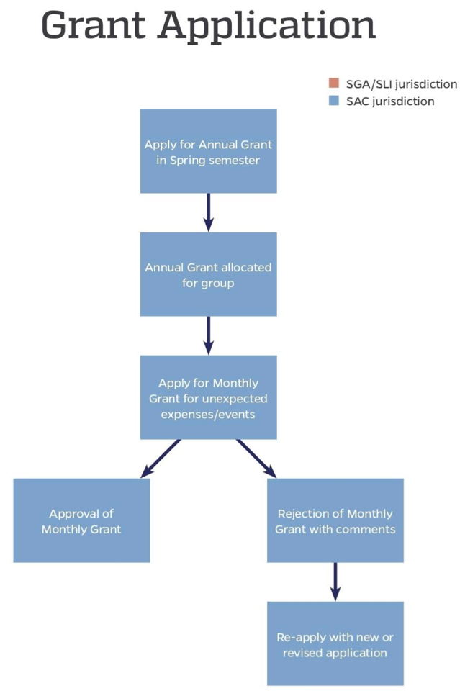
- The Application Process
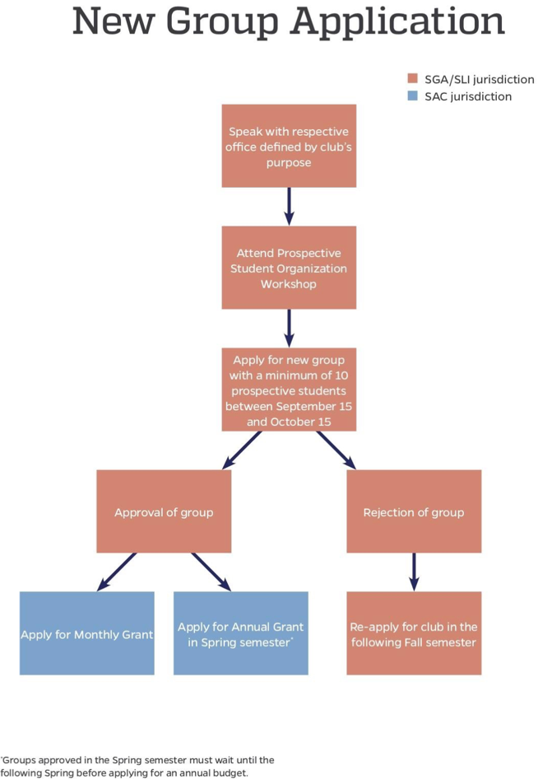

- Communicating with the S.A.C.
  - A category liaison is the first point of contact between the S.A.C. and all student groups.
  - The category liaison information will be provided on the S.A.C. website and at the bottom of all S.A.C Emails.
  - The liaison will be open to answer any questions about the application process, the guidelines, or a group’s financial situation.
- Collaborating Organizations
  - The S.A.C. highly encourages groups to collaborate with other organizations.
  - The S.A.C. will only look at one grant submitted for a single event. If two or more groups are involved in an event and create more than one grant application, only the lowest requested amount for the event will be looked at by the S.A.C.
- New Student Groups
  - New student groups approved during the fall semester are eligible to apply for an annual budget at the end of the following spring semester.
  - New student groups approved during the spring semester are not eligible to receive an annual budget during the same semester and must wait until the following school year’s spring to apply for annual budgets.
  - The groups are eligible to apply for monthly grant funding in the month immediately following their approval as a club from the SGA general body.
  - New student groups and provisional groups are also eligible for up to a $100 start­up grant payable directly through the SGA Executive treasurer, Eric Armstrong.
  - Upon approval as a new group, groups will be assigned a liaison within the S.A.C. who will be the first point of contact relating to any financial matters or questions that may arise.

Funding Categories

If you request more than the budget cap, your request will be cut to at most the listed amount at a maximum.

Independent Contractors
Annual Budget Cap: $1500
Definition:
- Funds used for contracted speakers, performers, and other acts paid via a federal identification number
Eligibility
- JHU employees may not be paid as independent contractors.
- An individual student may be paid as an independent contractor, provided that the student offers the service at lowest reasonable cost.
- Students may not be paid for services if they are active members of the group funded.

Non-JHU Professional Services:
Annual Budget Cap—$3000
Definition:
- Funds used for OUTSIDE JHU independent contractors (individuals paid via a social security number), such as sound and lighting technicians, graphic designers, etc.
Eligibility
- The SAC may fund the payment of professionals for services rendered for SAC groups, provided that:
- The events hosted by any such professionals are made open to all full-time undergraduates of The Johns Hopkins University
- The professional is not an employee of the University
JHU Professional Services
Annual Budget Cap—$2000
Definition:
- Funds used for university services, such as security, audio/visual, plant operations, and university rentals (excluding Zipcars), where:
  - The service is provided through JHU
  - The student group is being charged for the service
Eligibility
- The SAC will not fund pay to individual Hopkins employees

Non-Reusable Items
Annual Budget Cap—$500
Definition:
- Non-reusable goods are those items which can only be used once
  - This includes paper goods (plates, napkins, etc.), royalties, film copyrights, name tags etc.
  - Items must be classified as non-reusable or reusable (such as clothing for dance groups, costumes)
Eligibility
- The SAC will not fund prizes of any nature.
- The SAC will not fund clothing as a non-reusable item
Reusable Items/Supplies & Equipment
Annual Budget Cap—$1500
Definition:
- Items that can be used time and again by a group
- Items must be classified as non-reusable or reusable (such as clothing for dance groups, costumes)
- Office supplies and costumes also fall under this category
Eligibility
- Items MUST stay within organization in storage after use if classified as reusable
- Will not fund purchase of club equipment which is to be stockpiled and not made available at all time to the full time undergraduates such as private art/book/video collections
- The SAC will not fund t-shirts, jerseys, or any other personal clothing.
- The SAC will only fund clothing if it is a costume that will be reused by the organization. Members are expected to purchase any clothing that they plan on keeping.
- The SAC will not fund religious supplies. ▪ e.g. prayer books, candles, pendants, etc.
- Storage
  - Any funding request which includes the purchase of a reusable item must include one of the following:
    - An on-campus location which has been allotted for its storage
    - The name, JHED ID, and signature of the club member who accepts responsibility for the item, and who will maintain the item in their possession
Registration Fees
Annual Budget Cap—$1500
Definition:
- Funds used for conference fees and registration for performances, competitions etc.
- This does not include food, travel, lodging, etc.
Eligibility
- Registration fees should be requested after qualification/attendance at event is confirmed unless this is a time sensitive issue if this is the case event registration should be accounted for in annual budget
  - If registration is requested tentatively then treasurer reserves the right to withdraw funds
Food
Annual Budget Cap: $1500
Definition:
- Any and all food used for an event
Eligibility
- No funding for food during regular meetings
- Food must be essential to the event. This means that the food must play an integral role in the event and should not be just having food at an event.
  - Example of food essential event: Dumpling Making.
  - Example a non-food essential event: A cultural art showcase with food or a lecture and dinner.
- In order to receive funding for food, student groups must provide an explanation of the need for food for the event.
- No food funding for general body meeting, banquets, performances, etc
- Food must only be for JHU affiliates

Travel
Annual Budget Cap—$1500
Definition:
- Any cost incurred to leave campus. This includes transportation, lodging and food for trips.
Eligibility
- Travel only for competing, volunteering, performing, or other reasons deemed essential
- Travel must be essential to the group’s mission
- Only fund for continental U.S. travel
- The goal of travel cannot be for the whole group to travel as a result of budget limitations
- Will not fund travel travel for:
  - Travel by personal or rental car if it is over 300 miles roundtrip. Per the policy set forth by JHU Risk Management, all travel over 300 miles roundtrip must be done via public transportation (i.e., plane, train, or bus)
  - Costs of repairs, in the event of an accident or malfunction
  - Travel to private events

Formals and private events
- SAC will not fund private events restricted to only club members.
- All SAC funded activities must be open to the campus community and provide a positive impact to the campus community.
- This means that SAC will not fund Formals, Senior Gifts, or other purchases that are just gifts for club members.

Printing/Advertising
Annual Budget Cap:
- Flyers: $100
- Bound publication: $200
- Newsprint: $2600
- Social Media Promotion/Online Presence: $100

Pricing Information
Electricity: If your event requires access to outdoor electrical outlets or
has special electrical needs, you will need to hire an electrician to help
with your event. Please work with Scheduling and Event Services to
reserve an electrician:
o Hourly Rates:
Monday thru Friday, 7:30 AM – 4 PM: $46.65
Weekends or before 7:30 AM after 4 PM: $69.95/hour (4-
hour minimum)

Grounds: If your event requires special outdoor setup, waste or trash
pick-up from outdoor events, installation of temporary fencing, or grilling
of any type you will need to hire Grounds to help with your event.
Please work with Scheduling and event services to schedule
groundskeepers:
o Hourly Rate:
Monday thru Friday, 6:30 AM – 3 PM: $42.35/hour
Weekends or before 6:30 AM after 3 PM: $63.50/hour (4-
hour minimum)

Custodial: If your event will need additional custodial coverage outside
of their normal rounds, in areas such as restrooms, or for trash removal
it may be recommended to request additional custodial services. This is
usually only for all-day events or events expect high attendance.
Scheduling and Event Services can help you determine if additional
support is needed for your event. There are also additional setup fees
associated with having any rented tables, chairs, etc. set up both inside
or outside. Your group will be charged if they rearrange the furniture in a
room and do not return it to its original setup. Most evening and
weekend events in Shriver Auditorium will require custodial overtime
o Hourly Rate:
Monday thru Friday, 6:30 a.m.–3 p.m.: $33.70/hour
Weekends, before 6:30 a.m. or after 3 p.m.: $50.55/hour (4-
hour minimum)

Security: JHU’s preferred security vendor is Wolf Management. When
you register your event on Hopkins Groups, Student Leadership and
Involvement staff will determine if your event needs security personnel
to staff the event. Please be advised that Wolf charges a 4-hour
minimum and requires at least one supervisor to be on staff.
o Hourly rates
Officer: $16.75/hour
Supervisor (Required): $19.50/hour
JHU Officer: $30 per hour

Baltimore City Police $45 per hour
Lodging: JHU’s preferred lodging vendor is the Inn at the
Colonnade. Please fill out the travel request form and work
with the budget specialist in SLI to reserve rooms. Typical
prices are around $189/night.
Film Rights: Movie rights from Swank.com range from
$371 to $871, depending on the year the movie was
released. Obtaining film rights is MANDATORY to show a
film on campus. It is illegal to stream movies from movie/TV
subscription services such as Netflix or Hulu in any public
space on campus. Please refer to the Undergraduate
Organization Policies &amp; Procedures for more information.
Waste Bin Delivery Costs: If there will be trash produced
with your event, you will need to order additional waste bins
from Recycling Services. Please work with Scheduling and
Event Services to determine if additional bins are needed
and to place your order. Depending on your needs and the
type of trash produced, Recycling Services can provide
trash, recycling, and compost bins.
o Hourly rates
Monday through Friday, 8:30 a.m.–5 p.m.:
$33.70
Weekends, before 8:30 a.m. or after 5 p.m.:
$50.55 (4-hour minimum)

o Hourly charges for waste delivery and collection will
be charged as follows:
1-100 people = 1 hour
101-200 people = 2 hours
201-300 people = 3 hours
301+ people = 4 hour

Van Program: All registered student organizations are eligible to rent
Hop Vans. Please consult the Van Program website for more details.
There is a charge of $15.00 per rental day plus $0.65 per mile. Usage is
billed at $0.65/ mile but includes fuel. This is subject to change based
on current fuel prices.
Event Hours: Staffing and services will not be available earlier than the
times listed below. You should plan to start your event a minimum of 30
minutes after the event hours start in order for staffing and support to be
in place. For every additional hour prior to event hours you require
services, you will be charged $75 an hour.

o Charles Commons, Levering, Shriver, Mattin, Outdoor spaces,
Mason, AMR, Wolman, and McCoy,
8:00 am-Midnight Monday- Friday (Events scheduled to end
at 11:30pm and spaces must be completely cleared by
Midnight.)
10:00 am-Midnight Saturday and Sunday (Events
scheduled to end at 11:30pm and spaces must be
completely cleared by Midnight.)

Copies: Student Leadership and Involvement has a printing station that
student organizations can use for their printing needs. All copy jobs
should be for student group purposes. Anyone using the SLI copier will
need their group’s budget number. Groups can find their budget number
on Hopkins Group
Table, Chair, and tent rentals: Some buildings on campus are already
equipped with tables and chairs (see Building Information below). If you
are hosting an event in a space that does not have tables and chairs,
you can work with Scheduling and Event Services to place rental
orders:
o $85 delivery and pickup charge
o $8.75 per 8-foot table
o $1.35 per chair
o Tents prices vary based on size and type
o Please note that no outdoor spaces are equipped with tables and
chairs, and they will need to be rented if your event requires
tables and chairs.

Parking: Visitor parking permits for the South Garage can be obtained
through Parking Services. Parking permits are $12 each when
purchasing a minimum of ten permits. Services vehicle permits are $15
each. Unused passes may not be returned. South Garage and San
Martin Garage parking passes can be obtained through Scheduling and
Event Services.
A/V Rentals: Scheduling and Event Services will help you coordinate
A/V rentals and service as necessary. Some buildings on campus are
already equipped with A/V equipment and may only require set-up. If
your event location does not have A/V already installed, you must work
with Scheduling and Event Services to rent A/V equipment from Kit-
Cats. Please note, Student Organizations are not permitted to rent
A/V equipment from the Digital Media Center (DMC). DMC
equipment is for personal or academic use only. Below is a list of
commonly requested items and their rental rates:
o Labor (set-up): $50.00/hour

o Labor (Afterhours and weekends, 4-hour minimum): $50/hour
o LCD Projector: $160.00
o Lectern with PA: $60.00
o Speakers: $70.00

Disclaimer
Policy Changes
- All changes will be announced by an email from the Executive Treasurer of the SGA after the meeting at which the change was made.
- Upon approval of new funding guidelines, the SAC will begin funding under the newly approved guidelines at the following meeting.

SAC Discretion and Conditional funding
- While SAC guidelines describe the proper procedure for student group funding, the SAC reserves discretion to approve, deny, or table each budget and proposal on a case-by-case basis.
- The SAC may also attach conditions and requirements to any approved budget or proposal, at its discretion
- In the event that the SAC’s operations account becomes depleted, SAC is required to deny all funding requests.
- In the event SAC’s operations account has a negative balance, the Senate is required to conduct a full audit of SAC.

